Session 3 – Using events to control a game

The week we are going to learn how to control a game works using events.

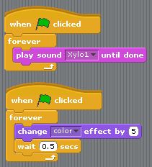**Step 1: Setup the background stage**

In the File menu, select ‘New’ to start a new game. This gives you a screen with a single ‘sprite’ (Scratchie) and a blank Stage.

The first thing you are going to do is set a different stage for the game. Select the blank white Stage in the bottom right of the screen. Select the “Backgrounds” tab and import a new background.

In this project we will use a background music loop and change the background a little while the game is playing. Select the “Sounds” tab on the stage and import a sound from the “Music Loops” folder. Then set it up to play continuously when Green Flag is clicked. Not too loud please ☺

**Step 3:**

We are now going to make an interactive quiz. First, change Scratchies costume by selecting the “Costumes” tab and import something from the Fantasy Folder. I used *witch1.*

Then you can make the main character fly up and down a little during the game. Add the moves on the right to her script:

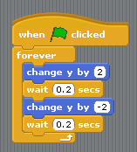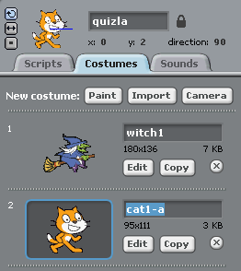

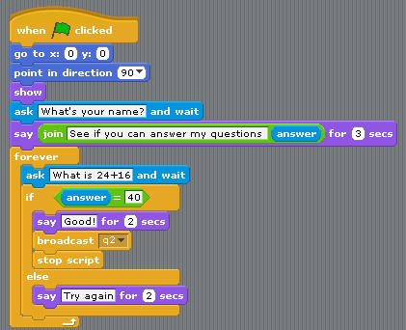**Step 4:**

Now let’s ask the first quiz question. You can use a math problem, something from history class, or whatever you like. There are a few new things here. “Ask and answer” are in the sensing block, they let you ask the user to type a value. You can then use to the answer block to retrieve the value. “Broadcast” is used to send all other sprites a message. Other sprites use “When I receive” to take action.

**Step 5: More questions**

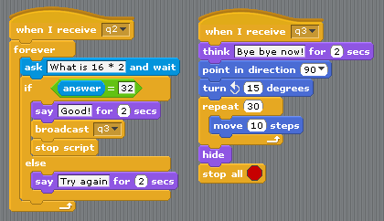Add another question and then fly off when the game is over. When the correct answer is given above, it sends a “q2” message to all sprites listening for that message. This starts the next question.

**Step 6: More project ideas**

* Add another question
* Make a new sprite and turn it into a frog if a question is answered wrong
* Keep count of wrong answers, if you miss more than once make something unexpected happen
* Add an event to your game from last week